**Michigan EAB project – chapter draft**

Aaron Tayal

June 23, 2025

**Introduction**

Forests are increasingly impacted by anthropogenic stressors, including the establishment and spread of nonnative species (Lovett et al. 2006). Exotic tree-feeding insects have been especially significant, causing economic and ecological impacts (Gandhi and Herms 2010, Van Driesche and Reardon 2016). These pests can undergo exponential population growth because top-down and bottom-up processes are reduced in the invaded range. Insects introduced to a new region of the globe can escape their specialist natural enemies which might otherwise control their populations (Roy et al. 2011, Duan et al. 2023). Furthermore, native tree species do not share a coevolutionary history with nonnative insects and may lack the necessary physical or chemical defenses (Villari et al. 2016, Mech et al. 2019). Release from these top-down and bottom-up controls can lead to rapid and widespread mortality of host trees. Tree mortality causes ecological consequences which have short- and long-term impacts on forest structure and function. In the short term, tree mortality forms canopy gaps that increase light availability and temperature and alter soil moisture on the forest floor (Perry and Herms 2019). Depending on the size, surrounding canopy and understory trees or advanced regeneration will respond to the available resources and grow to fill the gaps. If the host tree species has surviving seedlings, saplings, or root sprouts, this regeneration may compete to reclaim the space. However, regeneration of the host tree species can be hindered by the continual presence of the nonnative insect. Eventually, host tree species may be functionally eliminated from forests, or they may persist (McCormick and Platt 1980). If they do persist, they may do so in a different size range, or only within certain forest types (Barnes 1976).

Emerald ash borer (EAB, *Agrilus planipennis* Fairmaire) is an introduced woodboring beetle (Coleoptera: Buprestidae) that has had substantial direct and indirect ecological impacts in forests (Klooster et al. 2018). First identified near Detroit, Michigan in 2002, EAB has since spread throughout the eastern United States and Canada. Extensive mortality of North American ash (*Fraxinus* spp.) has occurred in regions where EAB has become established, including widely distributed white ash (*Fraxinus americana* L.), green ash (*Fraxinus pennsylvanica* Marsh), and black ash (*Fraxinus nigra* Marsh) (Burns and Honkala 1990). For example, mixed deciduous forests near the epicenter of the EAB invasion experienced more than 99% mortality of canopy ash by 2009 (Klooster et al. 2013). Ash trees with EAB larvae tunneling in their vascular system exhibit symptoms like bark splitting, sprouting along the trunk, canopy foliage dieback, and death (Knight et al. 2014). Concurrent with the death of mature ash, viable seed production declined precipitously, which threatens to eliminate the ash from forests (Klooster et al. 2013). To attempt control of EAB populations, several biological control agents native to east Asia have been widely released in eastern North America. Three parasitoid wasp species have established and are impacting EAB populations (Duan et al. 2015, 2023, Aker et al. 2022, Quinn et al. 2023).

Although the majority of mature ash have died, ash seedlings and saplings that were too small to be colonized by EAB during the initial wave of mortality are abundant in many forest understories (Aubin et al. 2015, Ward et al. 2021). If this regeneration grows large enough to reproduce and generate viable seeds, then ash could remain a long-term component of eastern North American forests. However, EAB populations in post-outbreak forests remain at low densities. As ash saplings grow to larger sizes, they become susceptible, increasing the likelihood that persisting populations of EAB will kill them (Duan et al. 2017). Recent evidence suggests that the introduced parasitoids could provide enough EAB-population control to protect regenerating ash in post-outbreak forests (Duan et al. 2015, McCullough 2019). *Tetrastichus planipennisi* Yang (Hymenoptera: Eulophidae) parasitizes EAB larvae through the thinner bark of young ash trees (<12 cm in diameter) (Abell et al. 2012, Duan et al. 2023), while the longer ovipositor of *Spathius galinae* Belokobylskij (Hymenoptera: Braconidae) may allow it to parasitize EAB larvae within ash trees up to about 39 cm in diameter (Murphy et al. 2017). Meanwhile, the tiny *Oobius agrili* (Hymenoptera: Encyrtidae) parasitizes EAB eggs in bark crevices (Quinn et al. 2023). The long-term persistence of ash populations in natural forests of North America will depend on the dynamic interactions among the cohort of immature ash in the forest understory, competing plants, low-density EAB populations, and introduced parasitoids.

Although EAB attacks ash trees in a variety of forest types (Smith et al. 2015), the long-term persistence of ash may occur only in a subset of the forest types which it once occupied. Forests where ash is found include abandoned agricultural fields (Morris et al. 2023), mixed hardwood forests on slopes (Royo and Knight 2012), riparian areas along streams (Engelken et al. 2020), river floodplains (Siegert et al. 2021), swamps formed from glacial lake plains (Abella et al. 2019), and depressional areas fed by ground or surface water (Golet et al. 1993). These forests can be classified using a variety of abiotic characteristics, but hydrology is one of the most impactful because of its effect on tree survival and species composition (Megonigal et al. 1997, Niinemets and Valladares 2006). Forest stands may be classified as xeric upland, mesic riparian, or hydric swamp. Different ash species thrive in different hydrological niches (Wagner and Todd 2015). For example, black ash is often a dominant species in hydric forests and has adaptations to deal with seasonal flooding (Telander et al. 2015, Kolka et al. 2018). Furthermore, hydric, mesic, and xeric forests may differ in the size distribution of ash trees, the abiotic stressors present, and the understory vegetation types, which can all impact ash regeneration success (Smith 2006, Engelken et al. 2020).

Given the uncertain future of ash in eastern North American forests, it is important to understand the potential for ash survival and regeneration in invaded forests with low-density EAB populations and a history of biological control releases. We resurveyed long-term forest research sites established during the early stages of ash mortality near the epicenter of invasion to investigate the occurrence and health of ash populations more than two decades after the detection of EAB. Our first objective was to quantify the abundance and health of ash regeneration in hydric, mesic, and xeric forests. We predicted that newly germinated seedlings would be absent due to a lack of seed-producing ash trees, and that the incidence of signs and symptoms of EAB would increase with increasing ash tree diameter (Klooster et al. 2013, Duan et al. 2017, Ward et al. 2021) due to the continued presence of EAB in these forests. Furthermore, we predicted that occurrence of ash regeneration would depend on soil hydrology of the forest, due to the associations between hydrology and ash species, canopy gap size, abiotic stressors, and understory vegetation dynamics. Our second objective was to evaluate whether introduced parasitoid natural enemies of EAB could be recovered at our sites. To further explore the responses in hydric forests, our third objective was to characterize changes in plant communities over time following the loss of ash.

**Methods:**

Study area

This study was conducted in 37 transects previously established in 2004-2008 in mixed hardwood stands on public land within the Upper Huron River Watershed in southeast Michigan (Table S1) (Smith 2006; Klooster et al. 2014; Smith et al. 2015). Forest transects were established in the Huron-Clinton Metroparks (Indian Springs, Kensington, and Hudson Mills) and Michigan State Recreation Areas (Pontiac, Highland, Proud Lake, and Island Lake) (Figure 1a). Transects were initially characterized by the dominant ash species present (*F. americana*, *F. pennsylvanica*, or *F. nigra*) and hydrologic conditions (xeric, mesic, or hydric soils). Transects in well-drained upland forests with white ash were classified as xeric (19 transects). Transects with moderately well-drained soils with mostly green ash were classified as mesic (8 transects). Transects in floodplains with water-saturated soils, standing water for part of the year, and black ash and/or green ash were classified as hydric (10 transects). Transects were located 24-45 km from the epicenter of EAB invasion in Canton, Michigan (Siegert et al. 2014), and have a long history of EAB. EAB was present in most transects in 2004-2005, and 99% of ash above 2.5 cm diameter were killed by 2009 (Klooster et al. 2013). Aside from hydrology, transects also varied in total tree basal area and density, tree species diversity, and ash basal area and density (Smith et al. 2015). Other than ash, common tree genera included maple (*Acer*), oak (*Quercus*), cherry (*Prunus*), hickory (*Carya*), tuliptree (*Liriodendron*), aspen and cottonwood (*Populus*), elm (*Ulmus*), basswood (*Tilia*), hophornbeam (*Ostrya*), and musclewood (*Carpinus*) (Smith et al. 2015). The region is a post-glaciated landscape, with moraines forming the upland areas. In some cases, precipitation seeps through the moraines and fills lowland areas with mineral rich water (Kost and O’Connor 2003).

Within each transect, three replicate 18 m radius circular plots (0.1 ha) were previously established with a multiscale sampling design to facilitate vegetation surveys (Fig. 1b). Each plot was composed of an 18 m radius main plot, one nested 8 m radius subplot, and four 4 m2 microplots, one in each cardinal direction. When established in 2004-2008, all plots contained at least two mature ash trees. Additional details on plot establishment and characterization are provided in Smith (2006). In the main plot, subplot, and microplots, we resurveyed ash trees, saplings, and seedlings, respectively, during the growing seasons in 2024 (30 transects) and 2025 (the remaining 7 transects).

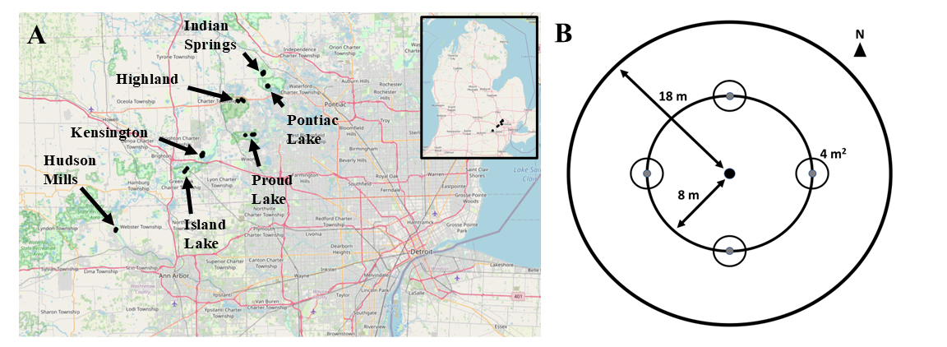

**Figure 1.** A) Map of southeast Michigan, showing the locations of the seven parks where forest stands were surveyed. B) Plot design, showing the 18 m radius main plot, the 8 m radius nested subplot, and the four 4 m2 area microplots located in cardinal directions.

Ash abundance and health

To assess the abundance and health of ash, canopy ash trees (≥10 cm diameter at breast height, DBH) were surveyed within the entire 18 m radius main plots, understory ash trees (2.5-10 cm DBH) and living ash saplings (≥137 cm in height but <2.5 cm DBH) were surveyed within the central 8 m radius subplots, and living ash seedlings (<137 cm in height) were surveyed within the 4 m2 microplots. All seedlings were checked for the presence of cotyledons which would indicate they were newly germinated (Klooster et al. 2013). Ash seedlings were counted in two height categories, <25 cm and >25 cm, and the percentage cover of ash seedlings in microplots was estimated (Klooster et al. 2013).

When present, canopy and understory ash (>2.5 cm DBH) were assessed individually for DBH, species, and health. All DBH measurements were taken at a height of 137 cm (Ward et al. 2021). Due to difficulties in distinguishing green and white ash, species designations were grouped into three categories: 1) black ash; 2) all other species of ash, including white ash, green ash, and potentially pumpkin ash (*Fraxinus profunda* Bush); and 3) unknown ash species because the tree was dead. After recording ash species, the tree was checked for signs and symptoms of EAB, including the presence of D-shaped emergence holes, woodpecker predation marks, bark splitting, epicormic sprouts, and basal sprouts. Furthermore, the canopy condition was rated using a 1 to 5 scale, where 1 represented a healthy canopy, 5 represented complete defoliation of the canopy (possibly still with living epicormic sprouts), and 2-4 represented increasing stages of decline (Smith 2006, Klooster et al. 2013, Knight et al. 2014). For statistical analyses, we simplified the canopy condition variable into two binary variables, *ash tree decline* and *ash tree death*. *Ash tree decline* was coded as 1 if the canopy condition showed any signs of decline (i.e. if canopy condition ≥ 2) and 0 if the canopy condition = 1. *Ash tree death* was coded as 1 if canopy condition = 5, and 0 otherwise (adapted from Hoven et al. 2020).

EAB trapping

In 2024, we used purple-prism traps and multi-funnel traps to assess EAB presence at six of the seven study parks (all except Hudson Mills Metropark, Table S2). Two purple-prism traps were installed at each park, for a total of 12 prism traps. Additionally, three multi-funnel (Lindgren) traps were installed at one park, Pontiac Lake Recreation Area. Traps were hung on or near the biggest ash trees that could be found in preliminary site visits. Traps were installed between May 29 and June 5, 2024 (627-734 GDD, base 50 °F, single sine method), and removed between July 23 and July 25, 2024 (1733-1770 GDD) (“Online Phenology and Degree-day Models” 2022). Purple prism traps used standard purple (“Coroplast purple”) colored board coated with glue (TAD Insect Trap Coating, Great Lakes IPM). Traps were hung at varying heights and near ash of varying size classes, depending on what was found at a park (Table S2). All traps were baited with Manuka oil and a fresh lure was installed halfway through the summer, between June 25 and July 3 (1146-1283 GDD). All buprestid beetles were removed from purple prism traps monthly, and from multi-funnel traps weekly, and EAB were counted and sexed (Parsons 2008).

Parasitoid sampling

In 2024, yellow pan traps were used to determine whether the introduced biological control agents were present at one of the parks, Pontiac Lake Recreation Area. Plot 53 at Pontiac Lake (Transect: M, Hydrology: mesic) was chosen because initial visits showed large numbers of regenerating ash. A yellow pan trap was composed of two nested yellow plastic bowls attached to the trunk of a small ash tree and filled with a collection liquid (USDA–APHIS/ARS/FS 2021). The USDA design was modified by using polypropylene webbing straps instead of nails to attach to the tree (Figure S2). On June 4, 2024, 15 traps were attached at a height of 5-6 feet to small green or white ash trees with diameters between 3.2 and 9.6 cm DBH (Table S3). The collection liquid was 20% propylene glycol in water, with 1 drop of unscented dish soap. Traps were collected weekly until August 8, 2024, by pouring the collection liquid through a fine mesh paint filter (listed as 190 micron, actually ~300 micron = 0.3 mm), and rinsing with distilled water. Since the smallest introduced parasitoid, *Oobius agrili*, averages 0.95 mm long (Zhang et al. 2005), a 0.3 mm mesh size was sufficient to collect all three parasitoid species. Paint filters were cooled on ice within 30 minutes and frozen within 1 day (USDA–APHIS/ARS/FS 2021).

To sort trap contents, a paint filter was placed into a petri dish and 70% isopropanol in distilled water was added. The introduced biological control agents of EAB were identified using USDA guidelines (USDA–APHIS/ARS/FS 2021), before being confirmed by expert identification (Toby Petrice, personal communication). Specifically, the pan traps were searched for *Tetrastichus planipennisi* (Chalcidoidea: Eulophidae: Tetrastichinae), *Spathius galinae* and *S. agrili* (Ichneumonoidea: Braconidae: Doryctinae) and *Oobius agrili* (Chalcidoidea: Encyrtidae). Besides these species, the overall insect communities in pan traps were investigated. The orders Hymenoptera, Coleoptera, Diptera (except small larvae < 1 mm), Lepidoptera, and Hemiptera were counted. All Hymenoptera except Symphyta were sorted to superfamily level (Goulet and Huber 1993). Within the Ichneumonoidea, the families Ichneumonidae and Braconidae were distinguished. Within Chalcidoidea, the families Mymaridae and Encyrtidae were distinguished (Schauff and Grissel 1990).

Vegetation survey in hydric transects

In 2025, non-ash canopy trees (≥12.5 cm DBH) and understory trees (2.5-12.5 cm DBH) were counted in the 18 m radius main plot and the 8 m radius subplot, respectively, to investigate which species of trees are found in the hydric plots. The threshold between understory and canopy was set at 12.5 cm to be consistent with previous studies (Klooster et al. 2013, Smith et al. 2015). Only the 10 transects (30 plots) classified as hydric were surveyed. Trees were identified to species if possible and rated as living or dead (dead trees could still have living epicormic sprouts). Trees that divided into two or more branches below breast height (137 cm) were considered as the same tree and were counted if their sum of diameters was greater than the threshold (12.5 cm for the main plot or 2.5 cm for the subplot). Stems putatively connected below ground by root systems were considered as separate trees (Abella et al. 2019). Ash trees were counted at the same transects in 2024, so only non-ash trees were counted when transects were revisited in 2025. Although ash trees in the 10-12.5 cm DBH range were counted in the main plot in 2024, these ash trees did not meet the 12.5 cm threshold and were not included in the results for the tree survey. In addition to tree surveys, percentage cover was estimated for woody shrubs, graminoids (grasses, cattails, and sedges), skunk cabbage (*Symplocarpus foetidus* (L.) Salisb.), ferns, and standing water. The percentage cover of the shrubs poison sumac (*Toxicodendron vernix* (L.) Kuntze), spicebush (*Lindera benzoin* L.), winterberry (*Ilex verticillata* (L.) A.Gray), and glossy buckthorn (*Frangula alnus* Mill.) were scored individually. Percentage cover was visually estimated for each of these categories by standing at 8 m in the NE, SE, SW, and NW quadrants of the 18 m radius plot. The four estimates for each cover type were averaged for a plot-level estimate.

Statistical analysis

Counts of ash canopy and understory trees, ash saplings, and ash seedlings were each summed across the three plots in a transect, which is the unit of replication. Density was calculated by dividing the count by the area over which they were counted. For canopy and understory trees, density of standing dead trees (canopy condition = 5) was calculated separately from density of living trees (canopy condition < 5). Basal area was calculated for living canopy and understory trees using the formula Σ(π*(d/2)2), where d is the DBH of each individual tree stem (Hoven et al. 2020). Multiple stems of a single tree were considered individually for basal area calculations but were considered as the same tree for tree counts.

The existing categorization of transects (n=37) by hydrological class (xeric: 19 transects, mesic: 8 transects, hydric: 10 transects, Table S1) was used to test whether the abundance of ash differs based on hydrology. The response variables were number of short ash seedlings (count), number of tall ash seedlings (count), mean percentage cover of ash seedlings (continuous), number of ash saplings (count), and number of living understory ash trees (count). Due to a low number of observations, the number of canopy ash (≥10 cm DBH) was not tested statistically. A separate model was created for each response variable. Hydrological class (xeric, mesic, or hydric) was treated as the fixed effect predictor and park where transect was located as random intercepts to account for unique site conditions at each of the seven parks. For each count response variable, a Poisson generalized linear mixed-effects model (GLMM) with a log link function was implemented using the package ‘lme4’ (Bates et al. 2015) in R (R Core Team 2024). The package ‘DHARMa’ was used to determine if the observed data was adequately modelled by the GLMM (Hartig 2024). Whenever the Poisson GLMM was determined to be overdispersed, a new model was created using the negative binomial error structure. This was implemented using the ‘lme4’ and ‘MASS’ (Venables et al. 2002) packages in R. The residuals of the negative binomial GLMM were similarly examined to verify model fit. Furthermore, the Akaike Information Criterion (AIC) was compared between the Poisson and negative binomial models to verify improvement in fit. The models for number of saplings and number of understory trees were singular fits, so the random effect of park for these response variables was dropped. For the mean percentage cover of ash seedlings, a linear mixed effects model with normally distributed residuals was used. The mean percentage cover was transformed using the function f(x)=ln(x+1) to satisfy the assumption of homogeneity of variances. For all response variables, the R package ‘car’ (Fox and Weisberg 2019) was used to test for overall differences between hydrological classes, and Tukey contrasts were calculated using the R package ‘emmeans’ (Lenth 2024).

To test the hypothesis that ash tree diameter would be positively correlated with signs and symptoms of EAB attack, generalized linear mixed-effects models with binomial error structure and logit link functions were implemented using the package ‘lme4’ (Bates et al. 2015). The binary (y/n) response variables tested were *woodpecker predation marks*, *bark splitting*, *epicormic sprouts*, *basal sprouts*, *ash tree decline*, and *ash tree death*. The fixed effect predictor variable was tree diameter at breast height (DBH). Plot was included as a random intercept to account for non-independence of trees in a plot. A Z-test was used to test the null hypothesis of no relationship between DBH and the EAB symptom. For our analysis, understory and overstory ash trees were pooled, and any tree was excluded if it belonged to a plot where less than 10 trees were found, which yielded a sample size of 283 trees (a cutoff of 5 trees in a plot was also tested and did not change the direction or significance of the results, Table S4). To assess the accuracy of the models, trees were binned into increments of 1 cm diameter, and the proportion of trees in each bin showing the EAB symptom was calculated. A model was judged as a good fit if the model trendline passed through the proportions for each bin.

To understand differences in forest community composition, the tree species composition of plots in 2024-2025 was investigated using nonmetric multidimensional scaling (NMDS). The Bray-Curtis dissimilarity between each of the 30 plots was calculated using the basal area (≥ 2.5 cm DBH) of each tree species, and the percentage cover of different ground-level vegetation types. Because basal area and percentage cover are on different scales, the plot × species matrix was standardized by dividing each cell by the maximum value in the column. Tree species were included in the analysis if they had ≥ 10 trees observed. The white oaks (*Quercus alba*, *Q. bicolor*, and *Q. macrocarpa*), red oaks (*Q. rubra* and *Q. palustris*), poplars (*Populus deltoides* and *P. grandidentata*), and elms (*Ulmus* sp.) were not identified to species level for the NMDS analysis.

**Results:**

In our survey of the 37 transects, we found 2981 ash seedlings, 1037 ash saplings, 276 living and 54 dead standing understory ash trees, and 7 living and 2 dead standing canopy (>10 cm DBH) ash trees. The basal area of living ash trees (≥ 2.5 cm DBH) at the transect level ranged between 0 and 2.60 m2/ha but averaged only 0.24 m2/ha. Ash seedlings were observed in 36 of the transects, but none had cotyledons (although two individual ash seedlings with cotyledons were found outside of microplot survey areas). Only four ash trees were found producing seeds near our study transects, including a 2.9 cm DBH green ash and three black ash trees ranging from 6.57 to 11.5 cm DBH. EAB adults were trapped at most parks, but in low densities (Figure S3). Three introduced biological control agents were recovered, *Spathius galinae* (3 individuals collected), *Oobius agrili* (2 individuals), and *Tetrastichus planipennisi* (2 individuals). Recovered introduced parasitoids comprised 0.46% (7/1537) of the Hymenoptera caught in pan traps.

Abundance of ash among forest types

The average density of ash seedlings ranged from 0-54,000 stems/ha (0-5.4 stems/m2), with an average of 16,500 stems/ha (1.65 stems/m2). Of these ash seedlings, those shorter than 25 cm in height had average densities of 8,800 stems/ha, while those between 25-137 cm in height had average densities of 7,800 stems/ha. Percentage cover of ash seedlings on the forest floor ranged from 0% to 38.1%, with an average of 10.7%. Both short and tall ash seedling densities, as well as percentage cover of ash seedlings, were lowest in hydric transects, relative to mesic and xeric transects (Figure 2A; short seedlings model: χ2=12.6322, 2 df, p=0.002; tall seedlings model: χ2=19.123, p<0.001, percentage cover model: χ2=17.721, p<0.001). The abundance of ash seedlings in mesic transects was also slightly higher than in xeric transects, but this was not statistically significant. The density of ash saplings ranged from 0-5390 stems/ha (0-0.539 stems/m2), with an average of 470 stems/ha (0.047 stems/m2). Numbers of ash saplings were similar among hydrological classes (χ2=0.26, p=0.88) (Fig. 2B).

A total of 330 understory ash trees (2.5-10 cm DBH) were found, and of these, 276 were living (canopy condition ≠ 5), while 54 were dead and standing. The density of living understory ash trees ranged from 0 to 1193.7 trees/ha, with a mean of 123.7 trees/ha. Hydric transects had more understory ash trees than xeric transects and marginally more understory ash trees than mesic transects (Fig. 2C; χ2=14.6, p=0.001). Of the 330 understory ash trees, 131 were identified as being green, white, or pumpkin ash, while 178 were identified as black ash, and 21 were unidentified *Fraxinus* (Figure S1). Only 9 canopy ash trees (≥ 10 cm DBH) were found in all the plots, of which 7 trees were living. Living canopy ash trees within the plots ranged in diameter from 10.3 cm DBH to 12.4 cm DBH.

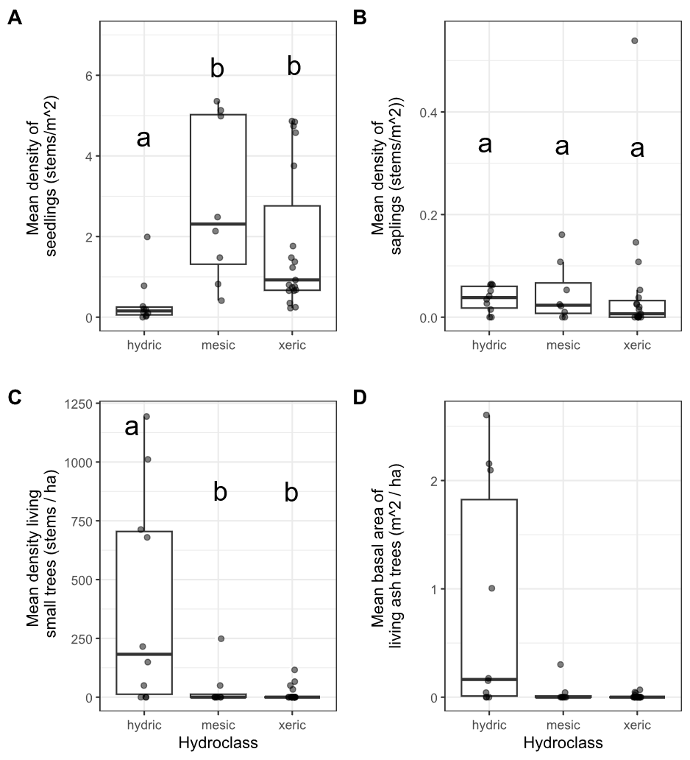

**Figure 2.** Ash occurrence in 37 transects in the Upper Huron River Watershed in southeast Michigan. The x-axis represents the soil hydroclass of the transect. Each data point represents a transect. Lowercase letters above bars indicate statistically significant differences at α=0.05. A) Mean density of ash seedlings (all ash with height < 1.37 m; short and tall seedling categories were combined for the graph), B) mean density of ash saplings (height ≥ 1.37 m and DBH < 2.5 cm), C) mean density of living understory ash trees (2.5 cm ≤ DBH < 10 cm), D) mean basal area of all living ash trees (DBH ≥ 2.5 cm). The basal area of living ash trees was not statistically investigated.

**Table 1.** Density (± standard error) of living ash (*Fraxinus*) regeneration in hydric (10 transects), mesic (8 transects), and xeric (19 transects) forests in the Upper Huron River Watershed in Southeast Michigan, USA. Only living trees are tabulated here. Data were collected in 2024 (97 plots) and 2025 (14 plots).

|  |  |  |
| --- | --- | --- |
| Size class | Hydrology class | Ash ha-1 |
| Short seedlings (<25 cm tall) | Hydric | 1,334 ± 952 |
|  | Mesic | 15,420 ± 4,920 |
|  | Xeric | 9,895 ± 2,458 |
|  | Combined | 8,776 ± 1,824 |
|  |  |  |
| Tall seedlings (25-137 cm tall) | Hydric | 2,381 ± 994 |
|  | Mesic | 13,085 ± 2,563 |
|  | Xeric | 8,351 ± 1,625 |
|  | Combined | 7,761 ± 1,189 |
|  |  |  |
| Saplings (>137 cm tall and <2.5 cm DBH) | Hydric | 360 ± 79 |
|  | Mesic | 472 ± 205 |
|  | Xeric | 517 ± 286 |
|  | Combined | 465 ± 152 |
|  |  |  |
| Understory trees (2.5 – 10 cm DBH) | Hydric | 401 ± 145 |
|  | Mesic | 37 ± 31 |
|  | Xeric | 14 ± 7 |
|  | Combined | 124 ± 48 |
|  |  |  |
| Canopy trees (>10 cm DBH) | Hydric | 2 ± 2 |
|  | Mesic | 0 |
|  | Xeric | 0 |
|  | Combined | 0 |

Signs and symptoms of EAB

Of the symptoms of EAB, bark splitting was the most common and was found on 193 (57%) ash trees (DBH ≥ 2.5 cm). Epicormic sprouts were found on 122 (36%) ash trees. Basal sprouts were found on 54 (16%) ash trees, while woodpecker predation marks were found on 46 (14%) ash trees. Out of a total of 338 trees, 229 (68%) had canopy condition=1 (meaning they were healthy), 33 (10%) had canopy condition=2, 13 (4%) had canopy condition=3, 7 (2%) had canopy condition=4, and 55 (16%) had canopy condition=5 (meaning they had a dead canopy). The D-shaped emergence holes from EAB were observed on a low percentage of ash trees, with only 8 trees (2%) recorded with visible exit holes.

The presence of woodpecker predation marks was positively correlated with tree diameter (DBH), with a 1 cm increase in DBH increasing the odds of woodpecker marks by a factor of 1.24 (Z=2.46, p=0.013) (Figure 3A). Similarly, presence of epicormic sprouts was positively correlated with DBH, with a 1 cm increase in DBH increasing the odds of epicormic sprouts by a factor of 1.31 (Z=3.49, p<0.001) (Figure 3C). The presence of canopy foliage decline was positively correlated with DBH, such that a 1 cm increase in DBH increased the odds of canopy decline by a factor of 1.22 (Z=2.89, p=0.004) (Figure 3F). Even though canopy decline was positively correlated with DBH, a sizeable proportion of the larger ash regeneration still had a healthy canopy: of the 127 standing ash trees above 5 cm DBH, 72 (57%) had canopy condition=1. No relationships were observed between DBH and bark splitting (Z=1.64, p=0.102), presence of basal sprouts (Z=1.16, p=0.245), and tree death (Z=0.21, p=0.831) (Figure 3, B, D, and E).

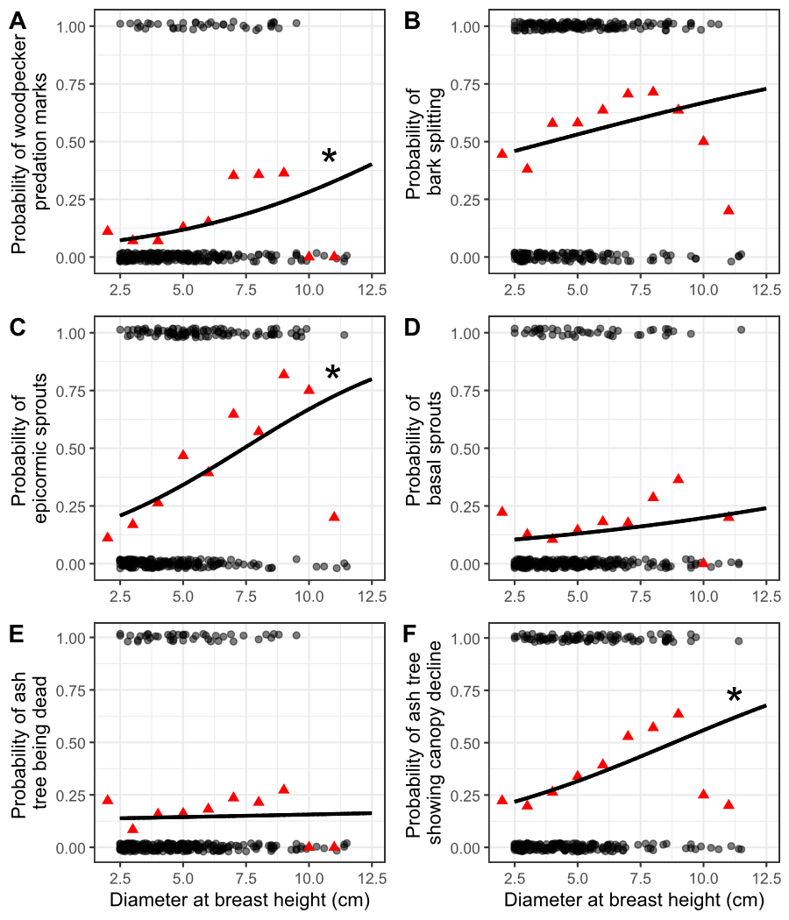

**Figure 3.** The presence or absence of symptoms of EAB plotted against tree diameter at breast height (DBH) for 283 ash trees. Trees were included in the analysis if they belonged to a forest plot containing at least 10 trees. Grey circles are individual trees, which are plotted as y=1 for presence or y=0 for absence (points were vertically jittered slightly). Black line shows the overall fitted model, disregarding each specific random intercept for each plot. See Figure S4 for plots including each random intercept. Asterisk next to the lines for woodpecker predation marks, epicormic sprouts, and canopy decline indicate a slope significantly different from zero. Red triangles show the proportion of trees that have the symptom within a DBH bin. For E, tree death is defined as having a canopy condition of 5. For F, canopy decline is defined as having a canopy condition between 2-5 (minor to complete defoliation).

Plant communities in hydric stands

We identified 810 living canopy trees comprising 18 genera in the 10 hydric transects (Table 2). The most common species in the canopy (≥ 12.5 cm DBH) was silver maple (*Acer saccharinum* L.), followed by elm (*Ulmus* sp.), and basswood (*Tilia americana* L.). In the understory (2.5 ≤ DBH < 12.5 cm), 638 living trees were found, of which the most common species were musclewood (*Carpinus caroliniana* Walter), black ash (*Fraxinus nigra*), and green ash (*Fraxinus pennsylvanica*, possibly with some *F. americana* and *F. profunda*). The basal area of living trees in the canopy and understory averaged 21.1 m2/ha and 2.8 m2/ha, respectively (not counting understory shrubs). Of the ground-level cover types estimated in hydric plots, graminoids and skunk cabbage had the highest percentage cover values (Table 3). The invasive shrubs glossy buckthorn and autumn olive (*Elaeagnus umbellata* Thunb.) were present, but with lower percentage cover values than the native shrubs spicebush and winterberry. The NMDS ordination (Figure 5) indicates a grouping of sample plots with high basal area of silver maple on the left side of the graph. Meanwhile, the upper center of the graph contains plots with species such as sugar maple (*Acer saccharum* Marshall). On the lower right side of the graph are plots with high basal area of yellow birch (*Betula alleghaniensis* Britt.) and/or tamarack (*Larix laricina* (Du Roi) K. Koch). The plots with high basal area of green ash tended to be in the forests with silver maple, whereas the plots with high basal area of black ash tended to be in forests with tamarack and/or yellow birch, although black and green ash also co-occurred in some plots.

**Table 2.** Relative density and relative dominance of tree genera found in the 10 hydric transects (30 plots) in 2024-2025. Only living trees are counted. Canopy trees are ≥12.5 cm DBH, while understory trees are 2.5-12.5 cm DBH. A total of 810 living canopy trees were counted in the main plots and 638 living understory trees were counted in the subplots. Shrub species were not counted.

|  |  |  |  |  |
| --- | --- | --- | --- | --- |
|  | Relative density, % | | Relative dominance, % | |
| Genus | Understory | Canopy | Understory | Canopy |
| *Acer* | 10.5 | 42.3 | 18.7 | 63.5 |
| *Betula* | 0.3 | 3.8 | 0.7 | 2.3 |
| *Carpinus* | 19.5 | 2.7 | 12.1 | 0.3 |
| *Carya* | 0.5 | 0.6 | 0.4 | 0.4 |
| *Cornus* | 0.5 | 0 | 0.2 | 0 |
| *Fagus* | 0.3 | 0.5 | 0.6 | 0.7 |
| *Frangula* | 7.5 | 0.1 | 3.7 | 0 |
| *Fraxinus* | 38.1 | 0 | 28.8 | 0 |
| *Juniperus* | 0 | 0.1 | 0 | 0 |
| *Larix* | 0.9 | 5.8 | 0.8 | 2.3 |
| *Ostrya* | 0.9 | 0.4 | 0.7 | 0.1 |
| *Populus* | 0 | 1.2 | 0 | 4.6 |
| *Prunus* | 0.3 | 0.5 | 0.3 | 0.4 |
| *Quercus* | 3.3 | 10 | 3.3 | 12.8 |
| *Rhamnus* | 0.2 | 0.1 | 0 | 0 |
| *Tilia* | 3.3 | 15.1 | 4.5 | 7 |
| *Ulmus* | 13.3 | 16.2 | 24.7 | 5.5 |
| *Viburnum* | 0.5 | 0.1 | 0.5 | 0 |

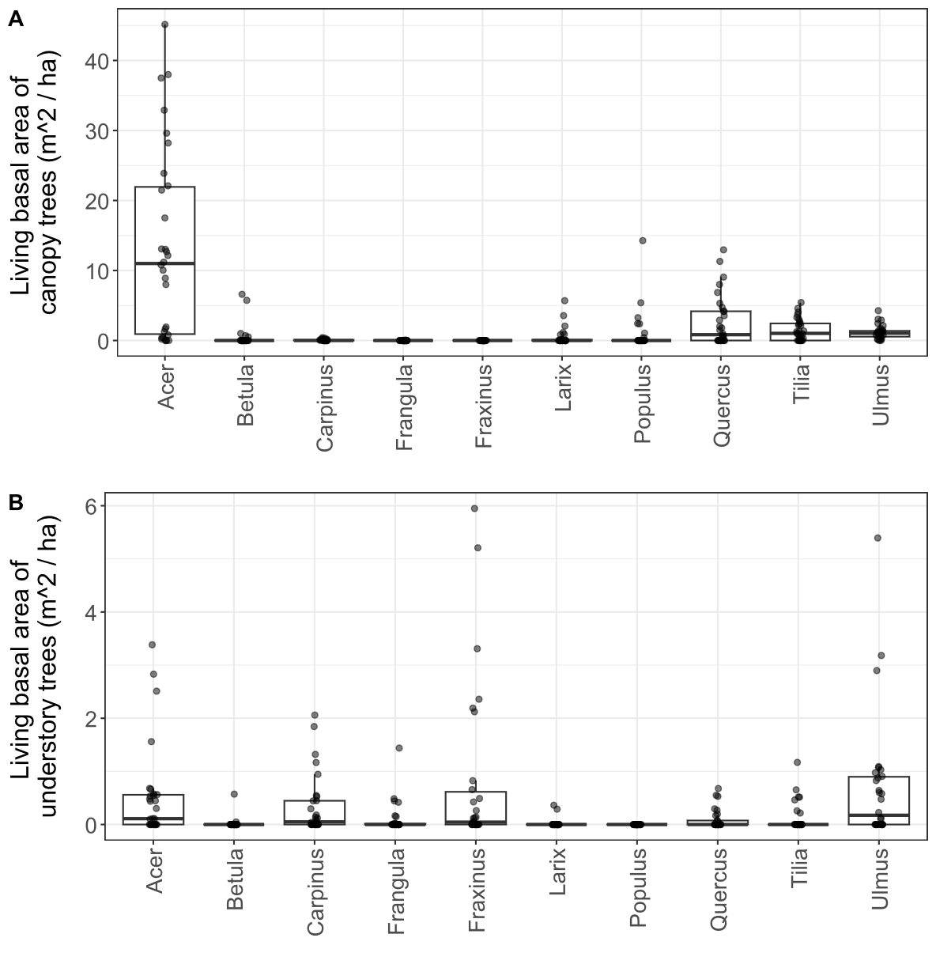

**Figure 4.** Basal area of living trees in 10 hydric transects (30 plots). Each dot represents a single plot. A) Canopy trees (≥ 12.5 cm DBH); B) understory trees (2.5-12.5 cm DBH). Tree genera were only included in the graph if their mean basal area was in the top seven for either canopy or understory trees. Note the difference in y-axis scale between the two graphs.

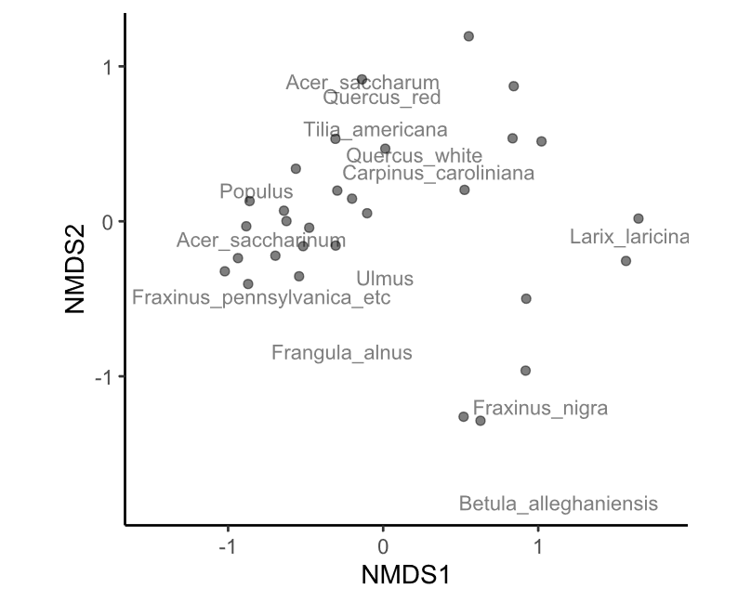

**Figure 5.** Nonmetric multidimensional scaling (NMDS) of the tree species composition at the 30 hydric plots visited in 2025. Each point is a plot. Data used to generate the NMDS was the basal area per hectare of each tree species, counting all trees ≥ 2.5 cm DBH. The final stress value was 0.149. Species within the red oak group (*Quercus* section *Lobatae*) were lumped together for the analysis, as were species within the white oak group (*Quercus* section *Quercus*) and the genera *Ulmus* and *Populus*.

**Table 3.** Average percentage cover (± SE) of understory cover types in 10 hydric transects (30 plots). Standard errors were calculated using n=30.

|  |  |  |  |  |
| --- | --- | --- | --- | --- |
| Cover type | Scientific name | Mean percent cover (%) ± SE | | |
| Water |  | 9.8 | ± | 2.6 |
| Graminoids | Poales | 52.7 | ± | 5.0 |
| Skunk cabbage | *Symplocarpus foetidus* | 37.6 | ± | 5.0 |
| Ferns |  | 16.5 | ± | 2.9 |
| Spicebush | *Lindera benzoin* | 19.2 | ± | 4.4 |
| Winterberry | *Ilex verticillata* | 5.7 | ± | 1.9 |
| Glossy buckthorn | *Frangula alnus* | 3.6 | ± | 1.2 |
| Poison sumac | *Toxicodendron vernix* | 2.1 | ± | 0.9 |
| Other woody shrubs | *Elaeagnus umbellata, Cornus* sp.*, Rosa* sp.*, Vaccinium* sp.*, Corylus* sp., etc. | 5.0 | ± | 0.8 |

**Discussion**

Over two decades since EAB was first detected in North America, we characterized ash survival and regeneration in forests that have experienced the longest history of EAB impacts. We found that ash regeneration was still present in these post-outbreak forests, although EAB continues to impact populations of ash. Ash regeneration remained at the seedling or sapling stages in mesic and xeric forests, but in hydric forests, ash regeneration consisted of trees in size classes susceptible to EAB. Parasitoids introduced to control EAB populations have established in the region, and we recovered three species, albeit in low numbers.

Stages of ash regeneration varied based on forest soil hydrology. In dry xeric and riparian mesic forests, ash seedlings were a prominent component of the understory layer, but ash trees (2.5-10 cm DBH) were mostly absent. In hydric swamp forests, we found low numbers of seedlings, but higher densities of small ash trees. This suggests a difference in growth rate, whereby ash regeneration was more advanced in hydric forests. In our study locations, the pre-EAB hydric transects had many more ash present in the canopy than mesic or xeric transects, which resulted in larger canopy gaps following EAB-induced ash mortality (Klooster 2012). Multi-tree gaps likely allowed surviving ash regeneration to grow quickly as EAB populations declined following canopy ash mortality. In contrast, mesic and xeric forests may have developed mostly single-tree gaps from ash canopy trees, allowing neighboring non-ash canopy trees to fill the gaps. Other studies support the hypothesis that compensatory growth by canopy trees was more important in upland sites than in forests that experience flooding. For example, Hoven et al. (2020) found that non-ash canopy trees grew faster in plots with more poor-condition ash canopy trees, but this relationship only held in xeric upland sites. Additionally, Davis et al. (2017) found that when black ash trees were girdled in a hydric forest in Upper Michigan, the non-ash canopy trees did not respond positively in the first three growing seasons.

Although ash seedlings were abundant in these post-outbreak forests, newly germinated ash seedlings were not observed in our long-term monitoring plots. Ash seedlings were abundant in mesic and xeric forests, but none had cotyledons, the seed leaves that would indicate new germination. This finding is consistent with…the more plausible scenario is that ash seedlings are simply persisting from before 2008, when new germination ceased (Klooster et al. 2013). In fact, the density of seedlings appears to have decreased, especially for the smallest seedlings, those < 25 cm tall. For instance, mesic transects had an average of 198,000 short ash seedlings ha-1 in 2010, but only 15,000 short ash seedlings ha-1 in 2024-25. Some of these short seedlings died, while others grew resulting in an increase in tall seedlings (25-137 cm) from 5,000 ha-1 in 2010 to 13,000 ha-1 in 2024-25 in mesic forests. Thus, regeneration is shifting to larger sizes while still not being replenished. In contrast to our results, another study of green ash swamps reported continuing seed production even after substantial EAB impacts (Kashian 2016). It is likely that in forests where ash trees make up the vast majority of trees in a stand, like in the study by Kashian, ash trees survive for longer after EAB introduction, and may continue to produce seeds, whereas in our study sites seed production ceased (Knight et al. 2013, Kashian 2016).

Our prediction that signs and symptoms of EAB would be more prevalent on ash trees of larger diameter was partially supported, but some ash trees in the 5-12.5 cm DBH range still had healthy canopies. We found that symptoms of EAB including the incidence of canopy decline, woodpecker predation marks, and epicormic sprouts all increased with increasing tree diameter. However, bark splits, basal sprouts, and tree death did not show any significant relationship with ash tree diameter. In particular, the distribution of bark splits across a range of ash diameters suggests that even some 2.5 cm DBH ash are being affected by EAB oviposition. Ash bigger than 4 cm DBH may be more suitable for larval development, but female EAB still oviposit on stems as small as 2 cm DBH (Timms et al. 2006, Aubin et al. 2015). Even though EAB symptoms were common, we still found sizeable numbers of small ash trees with healthy canopies. This stands in contrast to data from 2009, when almost no ash >2.5 cm DBH were living (Klooster et al. 2013). Although ash trees are recovering, they have not yet attained sizes larger than 12.5 cm DBH.

The high numbers of small ash trees in hydric forests motivated us to explore the vegetation communities in these post-EAB invasion forests. We found that silver maple was abundant, especially in the canopy. This species thrives in alluvial soils and is highly tolerant of seasonal flooding (Table S5) (Burns and Honkala 1990, Niinemets and Valladares 2006, Bolton et al. 2018). However, some transects were not dominated by silver maple, but instead contained many tamarack and sometimes yellow birch. These two species are typical of cooler, northern forests, whereas silver maple is commonly found further south of our study sites (Barnes 1976, Braun 1989, Burns and Honkala 1990, Kost and O’Connor 2003, Kartesz 2015). Regeneration of green ash primarily occurred alongside silver maple, whereas black ash regeneration was commonly associated with tamarack or yellow birch, although the two ash species were sometimes found in the same stands. Black ash is an important component of swamp forests in northern Michigan, Wisconsin, Minnesota, the northeast US, and Canada (Golet et al. 1993, Siegert et al. 2023). Similarly to our results, other studies of black ash regeneration after EAB invasion have found variable numbers of black ash in the 2.5-10 cm DBH range, but a near absence of black ash trees larger then 14 cm DBH (Siegert et al. 2021). Black ash in the 2.5-10 cm DBH range were common in gaps created by EAB (Engelken et al. 2020). Our results indicate that once 15 years have passed since peak EAB densities, black ash regeneration remains alive in many swamp forests. Although black ash only produces many seeds every 5-7 years, and the seeds can take 2 years to germinate, our observation of isolated seed production of black ash at Island Lake and Indian Springs indicates the possibility for black ash to persist in the forest (Benedict and David 2003).

Three species of parasitoids introduced to control EAB populations were recovered in these post-outbreak forests. Although they take time to build up populations, and consequently do not prevent the death of canopy ash trees, the parasitoids may be effective in post-outbreak forests (Jones et al. 2019). We recovered the larval parasitoids *T. planipennisi* and *S. galinae*, which work synergistically by parasitizing EAB on small and larger diameter stems, respectively (Duan et al. 2021). Furthermore, we captured the egg parasitoid *O. agrili* Although we recovered all three biological control agents known to have established in the region (refs), we collected these parasitoids in low abundance (7 individuals total). indicates the difficulty in using pan traps to assess introduced parasitoid establishment (Rutledge et al. 2021, Petrice et al. 2025).

Our findings in forests of southeast Michigan, 15 years after peak EAB populations, show that ash is still present in forests. Parasitoids may be playing a role in the health of the ash regeneration, but further research is necessary. Specifically, parasitoids should be surveyed in hydric swamp forests with regenerating black ash; most previous studies have focused on parasitoids in stands of green or white ash (Abell et al. 2014, Quinn et al. 2022b). We found that in hydric stands, small ash trees between 2.5-10 cm DBH were common, whereas in 2009 this size of tree had been completely killed by EAB. Furthermore, some regeneration exhibited symptoms of EAB, like epicormic sprouts, whereas others in the same stand appeared completely healthy. Multiple factors could be involved in the survival and growth of ash regeneration, including reduced EAB density due to declines in living ash phloem (Duan et al. 2015, Siegert et al. 2021), the development of ash tree resistance to EAB (Koch et al. 2015, Villari et al. 2016), site conditions including sunlight and water levels (Knight et al. 2013, Davis et al. 2017), and parasitoid natural enemies. Future research could focus on the host-location strategies of parasitoids, which could improve our knowledge of whether parasitoids could disperse to ash trees that are newly infested with EAB (Johnson et al. 2014, Chen et al. 2016, Wilson et al. 2024). In summary, the continued presence of ash in forests of southeast Michigan is far from guaranteed, but instead depends on multiple top-down and bottom-up ecological processes.

**Supplementary Information**

We tested whether the arthropod community differed between ash trees showing canopy decline (indicating possible EAB infection) vs. ash trees with a full canopy. To do this, we categorized the 15 ash trees as either healthy (Canopy condition = 1, 9 trees) or declining (Canopy condition > 1, 6 trees). We used ash tree health (healthy vs. declining) as the predictor variable. Our response variables were the total number individuals of each taxonomic group caught between June 27 and August 1 (these intervals were fully sorted into taxonomic groups). Specifically, we tested any groups for which >= 15 individuals were caught in total, including total number of arthropods, Symphyta (sawflies), Dryinidae (pincer wasps), Formicidae (ants), Pompilloidea (spider wasps), Apoidea (bees and sphecoid wasps), Ichneumonidae, Braconidae, Diapriidae (shelf-faced wasps), Ceraphronoidea, Mymaridae (fairy wasps), Encyrtidae, Platygastroidea, Diptera (flies), Hemiptera (true bugs), Lepidoptera (moths), and Coleoptera (beetles). We ran a Mann-Whitney U-test for each response variable.

**Supplementary Tables**

**Table S1.** Plot locations for the 111 plots visited in this study. Each set of three plots makes up a transect. Each transect was given a hydrological class of xeric (19 transects), mesic (8 transects), or hydric (10 transects). The plot numbers go up to 114 because they skip 46-48, because transect K (Smith 2006) was not visited.

|  |  |  |  |  |  |  |
| --- | --- | --- | --- | --- | --- | --- |
| **Plot**  **number** | **Plot name** | **Park** | **Transect** | **Latitude** | **Longitude** | **Hydrological**  **class** |
| 1 | KENUPHD | Kensington | A | 42.53254195 | -83.6705388 | xeric |
| 2 | KENUPHD2 | Kensington | A | 42.53296724 | -83.67076505 | xeric |
| 3 | KENUPHD3 | Kensington | A | 42.53326356 | -83.67093244 | xeric |
| 4 | HMHD | Hudson Mills | AA | 42.37834666 | -83.91336117 | mesic |
| 5 | HMHD2 | Hudson Mills | AA | 42.3779638 | -83.91309216 | mesic |
| 6 | HMHD3 | Hudson Mills | AA | 42.37830402 | -83.91382332 | mesic |
| 7 | KENDRY | Kensington | B | 42.53544514 | -83.66722319 | xeric |
| 8 | KENDRY2 | Kensington | B | 42.53563361 | -83.66642756 | xeric |
| 9 | KENDRY3 | Kensington | B | 42.53588209 | -83.66709668 | xeric |
| 10 | HMDRY | Hudson Mills | BB | 42.37515735 | -83.91411337 | xeric |
| 11 | HMDRY2 | Hudson Mills | BB | 42.37474575 | -83.91429938 | xeric |
| 12 | HMDRY3 | Hudson Mills | BB | 42.37398156 | -83.91421887 | xeric |
| 13 | KENUP | Kensington | C | 42.53463699 | -83.66695495 | xeric |
| 14 | KENUP2 | Kensington | C | 42.53497995 | -83.66657034 | xeric |
| 15 | KENUP3 | Kensington | C | 42.53429542 | -83.66721965 | xeric |
| 16 | ILOPEN | Island Lake | CC | 42.49941418 | -83.7165664 | mesic |
| 17 | ILOPEN2 | Island Lake | CC | 42.50011316 | -83.71690408 | mesic |
| 18 | ILOPEN3 | Island Lake | CC | 42.49984426 | -83.71729405 | mesic |
| 19 | KENDRY3 | Kensington | D | 42.53784433 | -83.66665362 | xeric |
| 20 | KENDRY3A | Kensington | D | 42.53794168 | -83.66596685 | xeric |
| 21 | KENDRY3B | Kensington | D | 42.53727952 | -83.66639485 | xeric |
| 22 | ILLOW | Island Lake | DD | 42.49971912 | -83.71630958 | hydric |
| 23 | ILLOW2 | Island Lake | DD | 42.50085549 | -83.7166848 | hydric |
| 24 | ILLOW3 | Island Lake | DD | 42.49794685 | -83.71775494 | hydric |
| 25 | PLINT | Proud Lake | E | 42.5759159 | -83.52099242 | xeric |
| 26 | PLINT2 | Proud Lake | E | 42.57601569 | -83.52054316 | xeric |
| 27 | PLINT3 | Proud Lake | E | 42.57637225 | -83.52026922 | xeric |
| 28 | HLMAT | Highland | EE | 42.64473456 | -83.56669535 | xeric |
| 29 | HLMAT2 | Highland | EE | 42.64590976 | -83.56680506 | xeric |
| 30 | HLMAT3 | Highland | EE | 42.64686284 | -83.56915982 | xeric |
| 31 | PLDRYMAT | Proud Lake | F | 42.57578816 | -83.52318352 | xeric |
| 32 | PLDRYMAT2 | Proud Lake | F | 42.57577574 | -83.52399007 | xeric |
| 33 | PLDRYMAT2A | Proud Lake | F | 42.57635459 | -83.52182426 | xeric |
| 34 | PLCONF | Proud Lake | G | 42.57571524 | -83.52814029 | xeric |
| 35 | PLDRYMAT3 | Proud Lake | G | 42.57581763 | -83.52740826 | xeric |
| 36 | PLDRYMAT3A | Proud Lake | G | 42.57607392 | -83.52668128 | xeric |
| 37 | PLWET | Proud Lake | H | 42.5747667 | -83.54598723 | hydric |
| 38 | PLWET2 | Proud Lake | H | 42.57474279 | -83.54632682 | hydric |
| 39 | PLWET3 | Proud Lake | H | 42.57428658 | -83.54708265 | hydric |
| 40 | KENWET | Kensington | I | 42.53043348 | -83.67041583 | hydric |
| 41 | KENWET2 | Kensington | I | 42.53110591 | -83.66746124 | hydric |
| 42 | KENWET4 | Kensington | I | 42.53118814 | -83.66648081 | hydric |
| 43 | KENWET3 | Kensington | J | 42.53124676 | -83.66897599 | hydric |
| 44 | KENWET3A | Kensington | J | 42.53101609 | -83.66944111 | hydric |
| 45 | KENWET3B | Kensington | J | 42.53146534 | -83.6685188 | hydric |
| 49 | PONUP | Pontiac Lake | L | 42.67601991 | -83.48374379 | xeric |
| 50 | PONUP2 | Pontiac Lake | L | 42.67639534 | -83.48336561 | xeric |
| 51 | PONUP3 | Pontiac Lake | L | 42.67695181 | -83.48354417 | xeric |
| 52 | PONHD | Pontiac Lake | M | 42.67737591 | -83.4842027 | mesic |
| 53 | PONHD2 | Pontiac Lake | M | 42.67763539 | -83.48494077 | mesic |
| 54 | PONHD3 | Pontiac Lake | M | 42.67619344 | -83.48458083 | mesic |
| 55 | PONEAST | Pontiac Lake | N | 42.67628637 | -83.48161802 | xeric |
| 56 | PONEAST2 | Pontiac Lake | N | 42.67644003 | -83.48223133 | xeric |
| 57 | PONEAST3 | Pontiac Lake | N | 42.67655527 | -83.4827693 | xeric |
| 58 | PONRT | Pontiac Lake | O | 42.67697644 | -83.48225793 | xeric |
| 59 | PONRT2 | Pontiac Lake | O | 42.67847161 | -83.4821571 | xeric |
| 60 | PONRT3 | Pontiac Lake | O | 42.67796779 | -83.48337831 | xeric |
| 61 | ILRIP | Island Lake | P | 42.50511387 | -83.711563 | hydric |
| 62 | ILRIP2 | Island Lake | P | 42.50548015 | -83.71130397 | hydric |
| 63 | ILRIP3 | Island Lake | P | 42.50506543 | -83.71105671 | hydric |
| 64 | ILCC | Island Lake | Q | 42.49871458 | -83.71880034 | hydric |
| 65 | ILCC2 | Island Lake | Q | 42.49826164 | -83.71911588 | hydric |
| 66 | ILCC3 | Island Lake | Q | 42.49755544 | -83.7194028 | hydric |
| 67 | ISMATDRY | Indian Springs | R | 42.70259786 | -83.49652337 | mesic |
| 68 | ISMATDRY2 | Indian Springs | R | 42.70213825 | -83.49648848 | mesic |
| 69 | ISMATDRY3 | Indian Springs | R | 42.70223513 | -83.49584728 | mesic |
| 70 | ISLD | Indian Springs | S | 42.7016922 | -83.49741597 | hydric |
| 71 | ISLD2 | Indian Springs | S | 42.70129243 | -83.49740698 | hydric |
| 72 | ISLD3 | Indian Springs | S | 42.70142849 | -83.49779967 | hydric |
| 73 | ISMATDE | Indian Springs | T | 42.7035437 | -83.49463936 | xeric |
| 74 | ISMATDE2 | Indian Springs | T | 42.70375308 | -83.49415138 | xeric |
| 75 | ISMATDE3 | Indian Springs | T | 42.70278921 | -83.49360562 | xeric |
| 76 | ISRIP | Indian Springs | U | 42.70463303 | -83.49570897 | hydric |
| 77 | ISRIP2 | Indian Springs | U | 42.70481219 | -83.494821 | hydric |
| 78 | ISRIP3 | Indian Springs | U | 42.70487822 | -83.4940807 | hydric |
| 79 | ISOPEN | Indian Springs | V | 42.70480262 | -83.49706373 | mesic |
| 80 | ISOPEN2 | Indian Springs | V | 42.70388702 | -83.49893342 | mesic |
| 81 | ISOPEN3 | Indian Springs | V | 42.7045196 | -83.49803841 | mesic |
| 82 | HLMATFR | Highland | W | 42.6489291 | -83.55636056 | xeric |
| 83 | HLMATFR2 | Highland | W | 42.64858561 | -83.55689617 | xeric |
| 84 | HLMATFR3 | Highland | W | 42.64939898 | -83.55761483 | xeric |
| 85 | HLRIP | Highland | X | 42.64587606 | -83.55093888 | mesic |
| 86 | HLRIP2 | Highland | X | 42.64514371 | -83.55089568 | mesic |
| 87 | HLRIP3 | Highland | X | 42.64637211 | -83.55062169 | mesic |
| 88 | HLUP | Highland | Y | 42.6470476 | -83.55230573 | xeric |
| 89 | HLUP2 | Highland | Y | 42.64705538 | -83.55397741 | xeric |
| 90 | HLUP3 | Highland | Y | 42.6474566 | -83.55365762 | xeric |
| 91 | HMMAT | Hudson Mills | Z | 42.37824499 | -83.91166168 | xeric |
| 92 | HMMAT2 | Hudson Mills | Z | 42.37825474 | -83.91229145 | xeric |
| 93 | HMMAT3 | Hudson Mills | Z | 42.3787298 | -83.91267589 | xeric |
| 94 | PONNEW | Pontiac Lake | ZA | 42.67554541 | -83.48274071 | xeric |
| 95 | PONNEW2 | Pontiac Lake | ZA | 42.67584028 | -83.4830424 | xeric |
| 96 | PONNEW3 | Pontiac Lake | ZA | 42.67606664 | -83.48271281 | xeric |
| 97 | PONRD | Pontiac Lake | ZB | 42.67546355 | -83.4821069 | mesic |
| 98 | PONRD2 | Pontiac Lake | ZB | 42.67597751 | -83.48183457 | mesic |
| 99 | PONRD3 | Pontiac Lake | ZB | 42.67611495 | -83.4822095 | mesic |
| 100 | PONWH | Pontiac Lake | ZC | 42.67657235 | -83.48190157 | xeric |
| 101 | PONWH2 | Pontiac Lake | ZC | 42.67696268 | -83.48095924 | xeric |
| 102 | PONWH3 | Pontiac Lake | ZC | 42.67670871 | -83.48046038 | xeric |
| 103 | ISBR | Indian Springs | ZD | 42.70640403 | -83.49342124 | hydric |
| 104 | ISBR2 | Indian Springs | ZD | 42.70623663 | -83.4938222 | hydric |
| 105 | ISBR3 | Indian Springs | ZD | 42.70670773 | -83.49360969 | hydric |
| 106 | ISBRS | Indian Springs | ZE | 42.70572744 | -83.49386673 | hydric |
| 107 | ISBRS2 | Indian Springs | ZE | 42.70535737 | -83.49412394 | hydric |
| 108 | ISBRS3 | Indian Springs | ZE | 42.70514295 | -83.49498565 | hydric |
| 109 | ISWH | Indian Springs | ZF | 42.70282112 | -83.49624363 | mesic |
| 110 | ISWH2 | Indian Springs | ZF | 42.70256049 | -83.49579452 | mesic |
| 111 | ISWH3 | Indian Springs | ZF | 42.70249606 | -83.49513887 | mesic |
| 112 | KENNEW | Kensington | ZG | 42.53359794 | -83.67122473 | xeric |
| 113 | KENNEW2 | Kensington | ZG | 42.53386003 | -83.67146597 | xeric |
| 114 | KENNEW3 | Kensington | ZG | 42.5343776 | -83.6712658 | xeric |

**Table S2.** Trap locations for the 2024 purple-prism and multi-funnel traps installed to assess EAB presence.



**Table S3.** Yellow pan trap information for 2024 parasitoid sampling effort. All traps were within ~30 meters of the center tree for Plot 53 at Pontiac Lake Recreation Area.

|  |  |  |  |  |  |  |  |  |
| --- | --- | --- | --- | --- | --- | --- | --- | --- |
| Trap number | DBH of ash (cm) | Canopy condition  (1-5) | EAB exit holes? | Woodpecker marks? | Ash bark splitting? | Epicormic sprouts? | Basal sprouts? | Canopy condition (binary) |
| 101 | 3.2 | 3 | n | n | y | y | y | Declining |
| 102 | 5.2 | 1 | n | n | y | n | n | Healthy |
| 103 | 6.6 | 1 | n | n | y | y | n | Healthy |
| 104 | 7.2 | 1 | n | n | y | y | n | Healthy |
| 105 | 3.1 | 3 | y | n | y | y | y | Declining |
| 106 | 5.9 | 1 | n | n | y | n | n | Healthy |
| 107 | 3.6 | 1 | n | n | n | y | n | Healthy |
| 108 | 4.45 | 1 | n | n | y | n | n | Healthy |
| 109 | 7.2 | 1 | n | n | y | y | n | Healthy |
| 110 | 8.9 | 1 | n | n | n | n | n | Healthy |
| 111 | 4.6 | 4 | n | n | y | y | y | Declining |
| 112 | 6.7 | 3 | n | n | y | y | n | Declining |
| 113 | 9.6 | 2 | n | n | n | n | n | Declining |
| 114 | 4.2 | 1 | n | n | y | y | n | Healthy |
| 115 | 9.1 | 4 | n | y | y | y | y | Declining |

**Table S4.** Statistical results for the model of the relationship between ash tree diameter and symptoms of EAB. The slope coefficient is the fitted coefficient which is multiplied by tree diameter within the model. The 10-tree criterion is where ash trees were only included if they belonged to plots where 10 or more ash trees were found. The models using the 10-tree criterion have n=283 trees (in 10 plots), while the models using the 5-tree criterion have n=305 trees (in 13 plots). The p-value is the probability, under the assumption that the true slope is zero, that we would find a slope coefficient larger in absolute value than the observed slope coefficient. Rows are bolded if the p-values were found to be less than 0.05.

|  |  |  |  |  |  |  |
| --- | --- | --- | --- | --- | --- | --- |
| EAB Symptom | Slope coefficient for 10 tree criterion | Slope coefficient for  5 tree criterion | Z value for 10 tree criterion | Z value for 5 tree criterion | p value for 10 tree criterion | p value for 5 tree criterion |
| **Woodpecker marks** | **0.2151** | **0.20432** | **2.461** | **2.429** | **0.0139** | **0.0151** |
| Bark splitting | 0.11505 | 0.10739 | 1.635 | 1.515 | 0.102 | 0.130 |
| **Epicormic sprouts** | **0.27194** | **0.25571** | **3.491** | **3.379** | **0.00048** | **0.000728** |
| Basal sprouts | 0.09990 | 0.09968 | 1.162 | 1.204 | 0.245334 | 0.228457 |
| Ash tree death | 0.01897 | 0.01139 | 0.214 | 0.135 | 0.830708 | 0.892797 |
| **Ash tree decline** | **0.20223** | **0.17223** | **2.886** | **2.531** | **0.00391** | **0.011377** |

**Table S5.** Waterlogging and shade tolerance copied directly from (Niinemets and Valladares 2006) for the common tree species found in the 30 hydric plots. Species were included if three or more individual trees were found.

|  |  |  |
| --- | --- | --- |
| Species | Waterlogging tolerance | Shade  tolerance |
| *Acer rubrum* | 3.08±0.28 | 3.44±0.23 |
| *Acer saccharinum* | 3.37±0.22 | 3.6±0.31 |
| *Acer saccharum* | 1.09±0.08 | 4.76±0.11 |
| *Betula alleghaniensis* | 2 | 3.17±0.16 |
| *Carpinus caroliniana* | 2.3±0.5 | 4.58±0.21 |
| *Carya ovata* | 1.38±0.08 | 3.4±0.29 |
| *Fagus grandifolia* | 1.5±0.06 | 4.75±0.14 |
| *Frangula alnus* | 3.19±0 | 2.66±0 |
| *Fraxinus nigra* | 3.5 | 2.96±0.43 |
| *Fraxinus pennsylvanica* | 2.98±0.25 | 3.11±0.11 |
| *Larix laricina* | 3 | 0.98±0.09 |
| *Ostrya virginiana* | 1.07±0.06 | 4.58±0.21 |
| *Populus deltoides* | 3.03±0.27 | 1.76±0.38 |
| *Populus grandidentata* | 2 | 1.21±0.27 |
| *Prunus serotina* | 1.06±0.06 | 2.46±0.34 |
| *Quercus alba* | 1.43±0.14 | 2.85±0.17 |
| *Quercus bicolor* | 2.58±0.28 | 2.98±0.02 |
| *Quercus macrocarpa* | 1.82±0.15 | 2.71±0.27 |
| *Quercus rubra* | 1.12±0.06 | 2.75±0.18 |
| *Tilia americana* | 1.26±0.15 | 3.98±0.15 |
| *Ulmus americana* | 2.46±0.26 | 3.14±0.12 |
| *Ulmus rubra* | 1.73±0.24 | 3.31±0.19 |

**Supplementary figures**

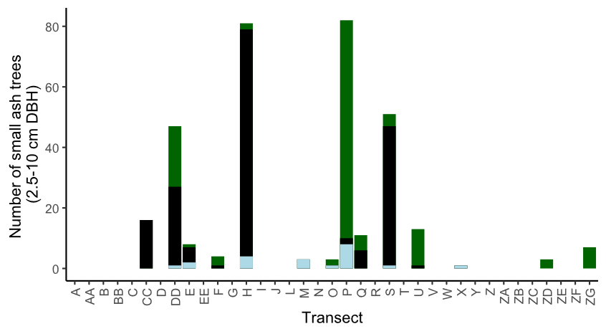

**Figure S1.** The total number of small ash trees (2.5 – 10 cm DBH) found in 37 transects in the Upper Huron River Watershed. Small ash of all canopy conditions are counted. Bars are shaded based on the proportion of each ash species that was found in a transect. Green represents green, white, and/or pumpkin ash; black represents black ash; light blue represents unknown ash species.

**Figure S2.** Yellow pan trap design using nested yellow bowls attached to a wooden stand and strapped to an ash tree.

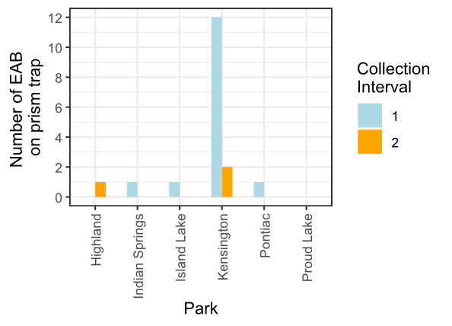

**Figure S3.** Captures of EAB adults from Prism traps in 2024. Collection interval 1 corresponds to June, while collection interval 2 corresponds to July.

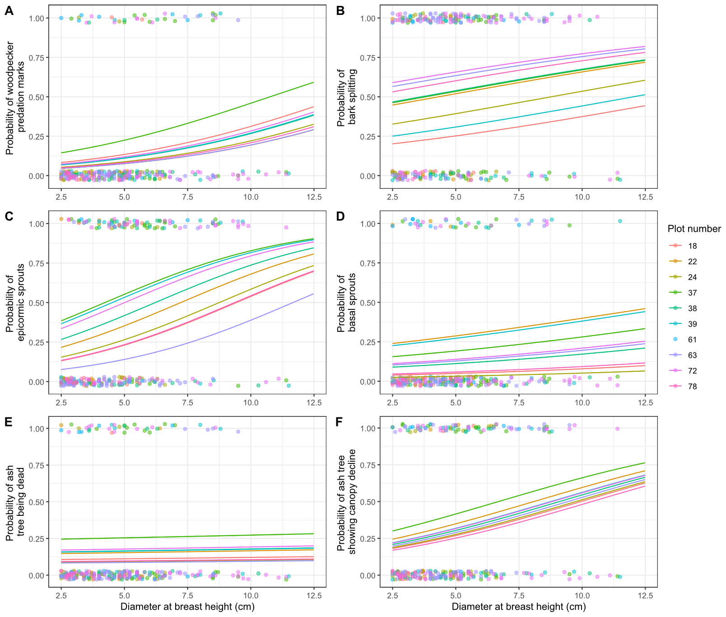

**Figure S4.** The presence or absence of symptoms of EAB plotted against tree diameter at breast height (DBH) for 283 trees in the 10 forest plots containing at least 10 trees. Colored points are individual trees, which are plotted as y=1 for presence or y=0 for absence (points were vertically jittered slightly). Points are colored based on the plot they belong to. Colored lines show the models for each estimated random intercept corresponding to each plot.

**References:**

Abell, K. J., L. S. Bauer, J. J. Duan, and R. Van Driesche. 2014. Long-term monitoring of the introduced emerald ash borer (Coleoptera: Buprestidae) egg parasitoid, Oobius agrili (Hymenoptera: Encyrtidae), in Michigan, USA and evaluation of a newly developed monitoring technique. Biological Control 79:36–42.

Abell, K. J., J. J. Duan, L. Bauer, J. P. Lelito, and R. G. Van Driesche. 2012. The effect of bark thickness on host partitioning between Tetrastichus planipennisi (Hymen: Eulophidae) and Atanycolus spp. (Hymen: Braconidae), two parasitoids of emerald ash borer (Coleop: Buprestidae). Biological Control 63:320–325.

Abella, S. R., C. E. Hausman, J. F. Jaeger, K. S. Menard, T. A. Schetter, and O. J. Rocha. 2019. Fourteen years of swamp forest change from the onset, during, and after invasion of emerald ash borer. Biological Invasions 21:3685–3696.

Aker, S. A., R. B. De Andrade, J. J. Duan, and D. S. Gruner. 2022. Rapid Spread of an Introduced Parasitoid for Biological Control of Emerald Ash Borer (Coleoptera: Buprestidae) in Maryland. Journal of Economic Entomology 115:381–386.

Aubin, I., F. Cardou, K. Ryall, D. Kreutzweiser, and T. Scarr. 2015. Ash regeneration capacity after emerald ash borer (EAB) outbreaks: Some early results. The Forestry Chronicle 91:291–298.

Barnes, B. V. 1976. Succession in deciduous swamp communities of southeastern Michigan formerly dominated by American elm. Canadian Journal of Botany 54:19–24.

Bates, D., M. Mächler, B. Bolker, and S. Walker. 2015. Fitting Linear Mixed-Effects Models Using **lme4**. Journal of Statistical Software 67.

Benedict, L., and R. David. 2003. Propogation protocol for black ash. Native Plants.

Bolton, N., J. Shannon, J. Davis, M. Grinsven, N. Noh, S. Schooler, R. Kolka, T. Pypker, and J. Wagenbrenner. 2018. Methods to Improve Survival and Growth of Planted Alternative Species Seedlings in Black Ash Ecosystems Threatened by Emerald Ash Borer. Forests 9:146.

Braun, E. L. 1989. The woody plants of Ohio: trees, shrubs and woody climbers, native, naturalized, and escaped. Ohio State University Press, Columbus, Ohio.

Burns, R., and B. Honkala. 1990. Silvics of North America: Volume 2, Hardwoods.

Chen, Y., M. D. Ulyshen, and T. M. Poland. 2016. Abundance of volatile organic compounds in white ash phloem and emerald ash borer larval frass does not attract *Tetrastichus planipennisi* in a Y‐tube olfactometer. Insect Science 23:712–719.

Davis, J. C., J. P. Shannon, N. W. Bolton, R. K. Kolka, and T. G. Pypker. 2017. Vegetation responses to simulated emerald ash borer infestation in *Fraxinus nigra* dominated wetlands of Upper Michigan, USA. Canadian Journal of Forest Research 47:319–330.

Duan, J. J., L. S. Bauer, K. J. Abell, M. D. Ulyshen, and R. G. Van Driesche. 2015. Population dynamics of an invasive forest insect and associated natural enemies in the aftermath of invasion: implications for biological control. Journal of Applied Ecology 52:1246–1254.

Duan, J. J., L. S. Bauer, and R. G. Van Driesche. 2017. Emerald ash borer biocontrol in ash saplings: The potential for early stage recovery of North American ash trees. Forest Ecology and Management 394:64–72.

Duan, J. J., J. R. Gould, N. F. Quinn, T. R. Petrice, B. H. Slager, T. M. Poland, L. S. Bauer, C. E. Rutledge, J. S. Elkinton, and R. G. Van Driesche. 2023. Protection of North American ash against emerald ash borer with biological control: ecological premises and progress toward success. BioControl 68:87–100.

Duan, J. J., R. G. Van Driesche, J. M. Schmude, N. F. Quinn, T. R. Petrice, C. E. Rutledge, T. M. Poland, L. S. Bauer, and J. S. Elkinton. 2021. Niche partitioning and coexistence of parasitoids of the same feeding guild introduced for biological control of an invasive forest pest. Biological Control 160:104698.

Engelken, P. J., M. E. Benbow, and D. G. McCullough. 2020. Legacy effects of emerald ash borer on riparian forest vegetation and structure. Forest Ecology and Management 457:117684.

Fox, J., and S. Weisberg. 2019. An {R} Companion to Applied Regression. Sage, Thousand Oaks {CA}.

Gandhi, K. J. K., and D. A. Herms. 2010. Direct and indirect effects of alien insect herbivores on ecological processes and interactions in forests of eastern North America. Biological Invasions 12:389–405.

Golet, F. C., J. A. Allen, U. S. Fish, and W. Service. 1993. Ecology of Red Maple Swamps in the Glaciated Northeast: A Community Profile. U.S. Department of the Interior, Fish and Wildlife Service.

Goulet, H., and J. T. Huber. 1993. Hymenoptera of the world: an identification guide to families. Agriculture Canada, Ottawa.

Hartig, F. 2024. DHARMa: Residual Diagnostics for Hierarchical (Multi-Level / Mixed) Regression Models. R.

Hoven, B. M., K. S. Knight, V. E. Peters, and D. L. Gorchov. 2020. Release and suppression: forest layer responses to emerald ash borer (Agrilus planipennis)-caused ash death. Annals of Forest Science 77:10.

Johnson, T. D., J. P. Lelito, and K. F. Raffa. 2014. Responses of two parasitoids, the exotic Spathius agrili Yang and the native Spathius floridanus Ashmead, to volatile cues associated with the emerald ash borer, Agrilus planipennis Fairmaire. Biological Control 79:110–117.

Jones, M. I., J. R. Gould, M. L. Warden, and M. K. Fierke. 2019. Dispersal of emerald ash borer (Coleoptera: Buprestidae) parasitoids along an ash corridor in western New York. Biological Control 128:94–101.

Kartesz, J. T. 2015. The Biota of North America Program (BONAP). North American Plant Atlas. (http://bonap.net/napa), Chapel Hill, N.C.

Kashian, D. M. 2016. Sprouting and seed production may promote persistence of green ash in the presence of the emerald ash borer. Ecosphere 7:e01332.

Klooster, W., K. Gandhi, L. Long, K. Perry, K. Rice, and D. Herms. 2018. Ecological Impacts of Emerald Ash Borer in Forests at the Epicenter of the Invasion in North America. Forests 9:250.

Klooster, W. S. 2012. Forest Responses to Emerald Ash Borer-Induced Ash Mortality. PhD Thesis, The Ohio State University.

Klooster, W. S., D. A. Herms, K. S. Knight, C. P. Herms, D. G. McCullough, A. Smith, K. J. K. Gandhi, and J. Cardina. 2013. Ash (Fraxinus spp.) mortality, regeneration, and seed bank dynamics in mixed hardwood forests following invasion by emerald ash borer (Agrilus planipennis). Biological Invasions 16:859–873.

Knight, K. S., J. P. Brown, and R. P. Long. 2013. Factors affecting the survival of ash (Fraxinus spp.) trees infested by emerald ash borer (Agrilus planipennis). Biological Invasions 15:371–383.

Knight, K. S., B. P. Flash, R. H. Kappler, J. A. Throckmorton, B. Grafton, and C. E. Flower. 2014. Monitoring Ash (Fraxinus spp.) Decline and Emerald Ash Borer (Agrilus planipennis) Symptoms in Infested Areas. General Technical Report, U.S. Department of Agriculture, Forest Service, Northern Research Station.

Koch, J. L., D. W. Carey, M. E. Mason, T. M. Poland, and K. S. Knight. 2015. Intraspecific variation in Fraxinus pennsylvanica responses to emerald ash borer (Agrilus planipennis). New Forests 46:995–1011.

Kolka, R., A. D’Amato, J. Wagenbrenner, R. Slesak, T. Pypker, M. Youngquist, A. Grinde, and B. Palik. 2018. Review of Ecosystem Level Impacts of Emerald Ash Borer on Black Ash Wetlands: What Does the Future Hold? Forests 9:179.

Kost, M. A., and R. P. O’Connor. 2003. Natural Features Inventory and Management Recommendations for Kensington and Oakwoods Metroparks. Michigan Natural Features Inventory, Huron-Clinton Metropolitan Authority.

Lenth, R. V. 2024. emmeans: Estimated Marginal Means, aka Least-Squares Means. R.

Lovett, G. M., C. D. Canham, M. A. Arthur, K. C. Weathers, and R. D. Fitzhugh. 2006. Forest Ecosystem Responses to Exotic Pests and Pathogens in Eastern North America. BioScience 56:395.

mapBioControl (Midwest Invasive Species Information Network). 2024. .

McCormick, J. F., and R. B. Platt. 1980. Recovery of an Appalachian Forest Following the Chestnut Blight or Catherine Keever-You Were Right! American Midland Naturalist 104:264.

McCullough, D. G. 2019. Challenges, tactics and integrated management of emerald ash borer in North America. Forestry: An International Journal of Forest Research 93:197–211.

Mech, A. M., K. A. Thomas, T. D. Marsico, D. A. Herms, C. R. Allen, M. P. Ayres, K. J. K. Gandhi, J. Gurevitch, N. P. Havill, R. A. Hufbauer, A. M. Liebhold, K. F. Raffa, A. N. Schulz, D. R. Uden, and P. C. Tobin. 2019. Evolutionary history predicts high‐impact invasions by herbivorous insects. Ecology and Evolution 9:12216–12230.

Megonigal, J. P., W. H. Conner, S. Kroeger, and R. R. Sharitz. 1997. Aboveground Production in Southeastern Floodplain Forests: A Test of the Subsidy-Stress Hypothesis. Ecology 78:370–384.

Morris, T. D., J. R. Gould, J. Drake, and M. K. Fierke. 2023. Status of ash forests and regeneration a decade after first detection of emerald ash borer infestation in New York state. Forest Ecology and Management 549:121464.

Murphy, T. C., R. G. Van Driesche, J. R. Gould, and J. S. Elkinton. 2017. Can Spathius galinae attack emerald ash borer larvae feeding in large ash trees? Biological Control 114:8–13.

Niinemets, Ü., and F. Valladares. 2006. Tolerance to Shade, Drought, and Waterlogging of Temperate Northern Hemisphere Trees and Shrubs. Ecological Monographs 76:521–547.

Online Phenology and Degree-day Models. 2022. . https://uspest.org/dd/model_app.

Parsons, G. 2008. Emerald Ash Borer: A guide to identification and comparison to similar species. Michigan State University Department of Entomology.

Perry, K., and D. Herms. 2019. Dynamic Responses of Ground-Dwelling Invertebrate Communities to Disturbance in Forest Ecosystems. Insects 10:61.

Petrice, T. R., T. M. Poland, L. S. Bauer, J. S. Strazanac, J. J. Duan, J. M. Schmude, and F. W. Ravlin. 2025. North American hymenopteran parasitoids of emerald ash borer larvae: seasonal abundance and interaction with introduced Asian parasitoids. The Canadian Entomologist 157:e7.

Quinn, N. F., J. J. Duan, and J. Elkinton. 2022a. Monitoring the impact of introduced emerald ash borer parasitoids: factors affecting Oobius agrili dispersal and parasitization of sentinel host eggs. BioControl 67:387–394.

Quinn, N. F., J. S. Gould, C. E. Rutledge, A. Fassler, J. S. Elkinton, and J. J. Duan. 2022b. Spread and phenology of Spathius galinae and Tetrastichus planipennisi, recently introduced for biocontrol of emerald ash borer (Coleoptera: Buprestidae) in the northeastern United States. Biological Control 165:104794.

Quinn, N. F., T. R. Petrice, J. M. Schmude, T. M. Poland, L. S. Bauer, C. E. Rutlege, R. G. Van Driesche, J. S. Elkinton, and J. J. Duan. 2023. Postrelease assessment of *Oobius agrili* (Hymenoptera: Encyrtidae) establishment and persistence in Michigan and the Northeastern United States. Journal of Economic Entomology 116:1165–1170.

R Core Team. 2024. R: A Language and Environment for Statistical Computing. R Foundation for Statistical Computing, Vienna, Austria.

Roy, H. E., L.-J. Lawson Handley, K. Schönrogge, R. L. Poland, and B. V. Purse. 2011. Can the enemy release hypothesis explain the success of invasive alien predators and parasitoids? BioControl 56:451–468.

Royo, A. A., and K. S. Knight. 2012. White ash (Fraxinus americana) decline and mortality: The role of site nutrition and stress history. Forest Ecology and Management 286:8–15.

Rutledge, C. E., R. G. Van Driesche, and J. J. Duan. 2021. Comparative efficacy of three techniques for monitoring the establishment and spread of larval parasitoids recently introduced for biological control of emerald ash borer, Agrilus planipennis (Coleoptera: Buprestidae). Biological Control 161:104704.

Schauff, M. E., and E. . Grissel. 1990. Key From: A handbook of the families of Nearctic Chalcidoidea (Hymenoptera). Entomological Society of Washington (Washington, D.C.) Handbook 1:1-85.

Siegert, N. W., P. J. Engelken, and D. G. McCullough. 2021. Changes in demography and carrying capacity of green ash and black ash ten years after emerald ash borer invasion of two ash-dominant forests. Forest Ecology and Management 494:119335.

Siegert, N. W., D. G. McCullough, T. Luther, L. Benedict, S. Crocker, K. Church, and J. Banks. 2023. Biological invasion threatens keystone species indelibly entwined with Indigenous cultures. Frontiers in Ecology and the Environment 21:310–316.

Smith, A. 2006. Effects of Community Structure on Forest susceptibility and Response to the Emerald Ash Borer Invasion of the Huron River Watershed in Southeast Michigan. Master’s Thesis, The Ohio State University.

Smith, A., D. A. Herms, R. P. Long, and K. J. K. Gandhi. 2015. Community composition and structure had no effect on forest susceptibility to invasion by the emerald ash borer (Coleoptera: Buprestidae). The Canadian Entomologist 147:318–328.

Telander, A. C., R. A. Slesak, A. W. D’Amato, B. J. Palik, K. N. Brooks, and C. F. Lenhart. 2015. Sap flow of black ash in wetland forests of northern Minnesota, USA: Hydrologic implications of tree mortality due to emerald ash borer. Agricultural and Forest Meteorology 206:4–11.

Timms, L. L., S. M. Smith, and P. De Groot. 2006. Patterns in the within‐tree distribution of the emerald ash borer *Agrilus planipennis* (Fairmaire) in young, green‐ash plantations of south‐western Ontario, Canada. Agricultural and Forest Entomology 8:313–321.

USDA–APHIS/ARS/FS. 2021. Emerald Ash Borer Biological Control Release and Recovery Guidelines. USDA–APHIS–ARS–FS, Riverdale, Maryland.

Van Driesche, R., and R. Reardon. 2016. The Use of Classical Biological Control to Preserve Forests in North America. USDA Forest Service, Morgantown, WV.

Venables, W. N., B. D. Ripley, and W. N. Venables. 2002. Modern applied statistics with S. 4th ed. Springer, New York.

Villari, C., D. A. Herms, J. G. A. Whitehill, D. Cipollini, and P. Bonello. 2016. Progress and gaps in understanding mechanisms of ash tree resistance to emerald ash borer, a model for wood‐boring insects that kill angiosperms. New Phytologist 209:63–79.

Wagner, D. L., and K. J. Todd. 2015. Chapter 2: Ecological Impacts of Emerald Ash Borer. Page Biology and Control of Emerald Ash Borer. USDA Forest Service.

Ward, S. F., A. M. Liebhold, R. S. Morin, and S. Fei. 2021. Population dynamics of ash across the eastern USA following invasion by emerald ash borer. Forest Ecology and Management 479:1–8.

Wilson, C. J., T. R. Petrice, T. M. Poland, and D. G. McCullough. 2024. Tree species richness and ash density have variable effects on emerald ash borer biological control by woodpeckers and parasitoid wasps in post-invasion white ash stands. Environmental Entomology 53:544–560.

Zhang, Y.-Z., D.-W. Huang, T.-H. Zho, H.-P. Liu, and L. S. Bauer. 2005. Two new species of egg parasitoids (Hymenoptera: Encyrtidae) of wood-boring beetle pests from China. Phytoparasitica 33:253–260.